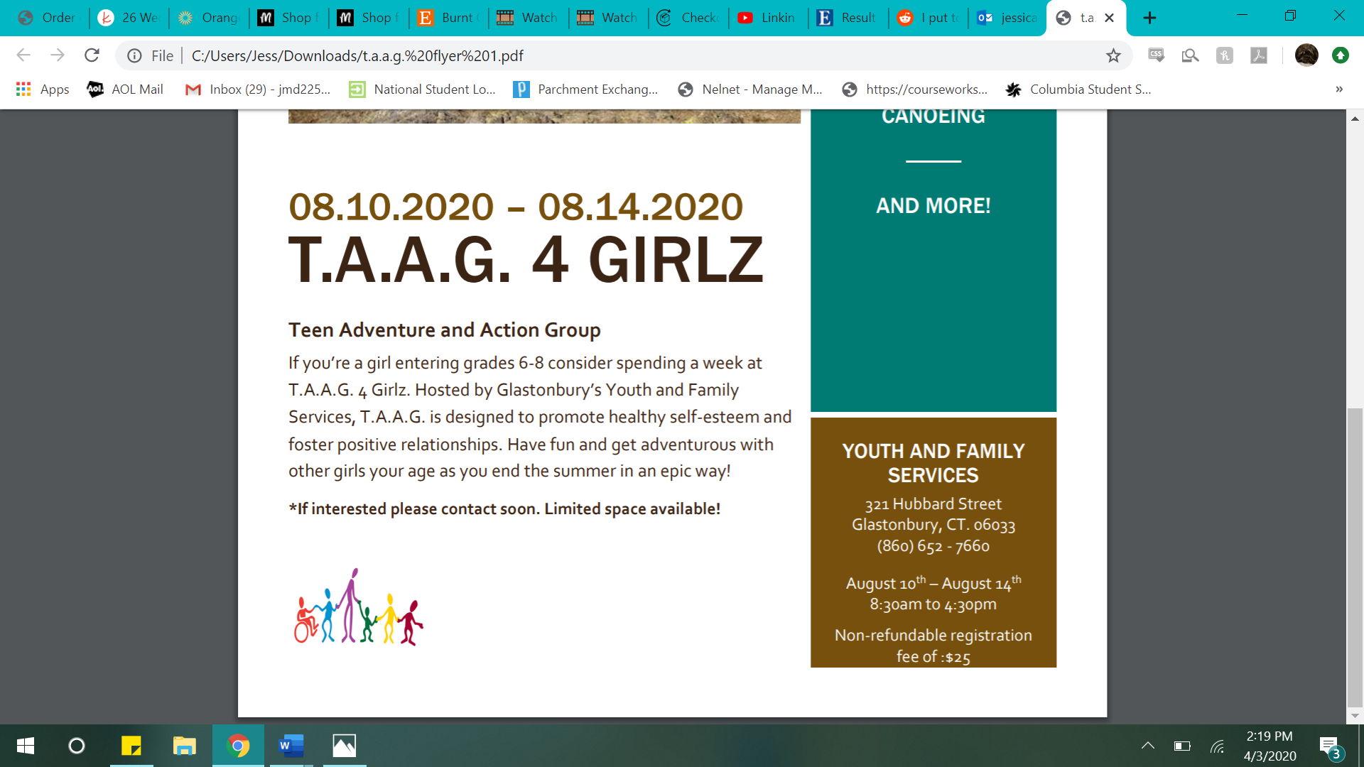

**Glastonbury Youth and Family Services**

These care kits were designed to offer some resources and strategies for coping with change brought on by COVID-19. Inside you’ll find:

* **Stress ball**
  + Instructions: Hold in your hand and squeeze slowly, but firmly. Breath in through your nose as you squeeze the ball, and slowly exhale as you release your grip.
* **Water beads**
  + Instructions: Place beads in a small bowl with ¼ cup of water. Allow to sit overnight. Run your hands through the completed beads when you are feeling anxious or stressed.
* **Coloring book** 
  + Instructions: Take some time to color when you are feeling overwhelmed. Not only is coloring a good attention taker and distraction, the repetitive motions can be soothing.
* **Fidget toy**
  + Instructions: Fidget toys are a great way to focus your nervous energy on something. You can play with it when you are feeling upset or as a way to help you focus while you’re doing something else.
* **Lotion**
  + Instructions: Self care is important! Give yourself a hand massage with this lotion. When you’re done, bring your hands to your face and take some deep breaths to enjoy the relaxing scent.
* **List of other coping tools**
  + Instructions: Read through the pamphlet of coping tools for ideas of things to do and apps to use when you are feeling depressed, anxious, or stressed.